

|  |  |  |
| --- | --- | --- |
| Mathematics Department | |  |
| Course: A1MAA | |
| **Topic Title:** Test 3 – Mensuration, similar figures and scale factors | |
| Student Name:_____________________________________ | Date: ____________ | | |
| Special Instructions: **Calculator Free** | Time Allowed: 30 minutes | | |
| Formulae Sheet | Marks: / 28 | | |
| Show all working | | | |

**Question 1 [1,2,2: 5 marks]**

(a) State the hypotenuse in this triangle.

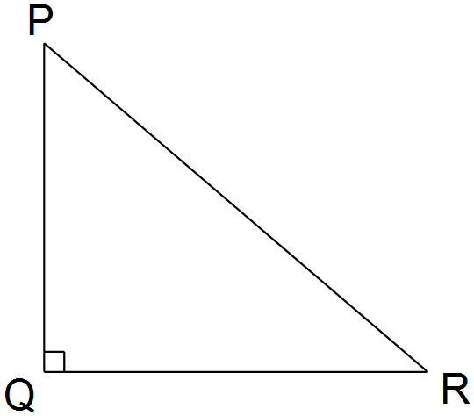

(b) A right angled triangle has sides 3, 4 and 5 cm long.

Complete Pythagoras’ Theorem, as it applies to this triangle.

 _____________

(c) Determine the missing lengths in these triangles.

(i) (ii)

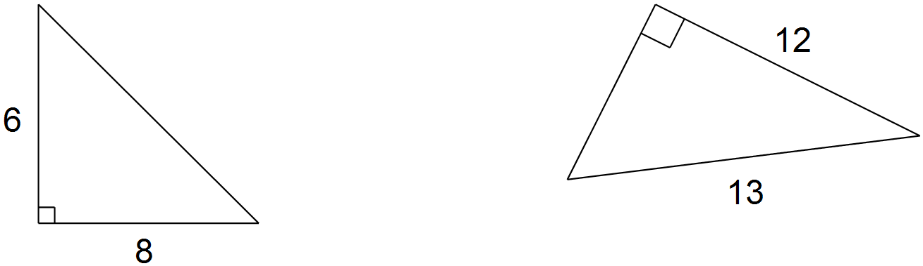

**Question 2 [2,1,2,2,2:9 marks]**

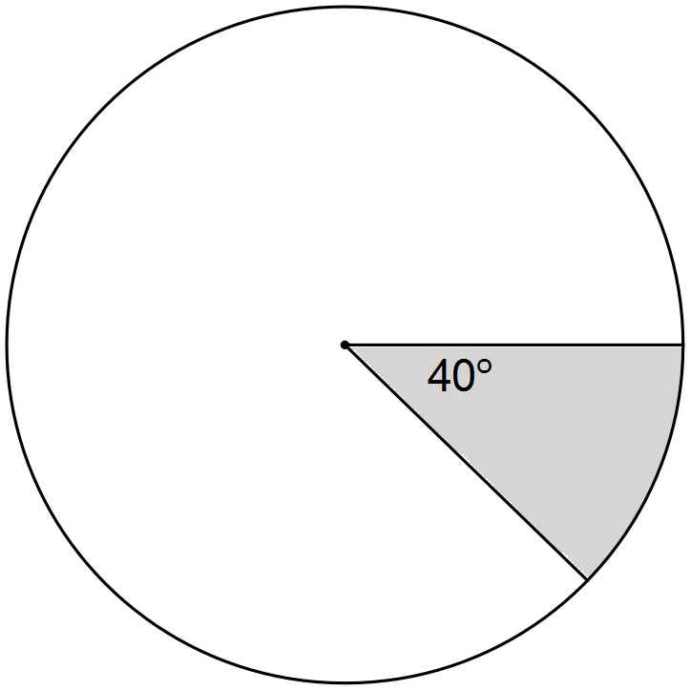

(a) The circular spinner drawn below has an area of 234 cm2.

Determine the area of the shaded section. (2 marks)

(b) The length of each side of a cubic die is 5 mm.

(i) Determine the total surface area of the die.

(ii) Determine the space occupied by the die.

(c) A fire started 600 m due East of Jason’s house and 800 m due South of Izzy’s house. Jason wants to go from his house to Izzy’s house.

(i) Draw a labelled diagram to show the locations of the two houses and the fire.

(ii) Determine the shortest distance from Jason’s house to Izzy’s house.

**Question 3 [2,3:5 marks]**

For a raised garden bed in the shape of a cylinder with radius (*r*) and height (*h*), the following rules apply:

1.  metres

2.  (in metres)

3. 

(a) From rules 1 and 2, determine the height, in **centimetres**, of the garden bed.

(b) By substituting the given value for the radius, determine a simplified expression for the volume of the garden bed in the form of  where *k* is a constant.

**Question 4 [1,1,1,2:5 marks]**

Jim and Bill are planning a series of triangular lawns in the school grounds. They are investigating the amount of water and fertiliser required and hence the areas of the lawns.

Three of the lawns they have investigated are drawn below: they are labeled A, B and C.

The diagrams are not to scale.

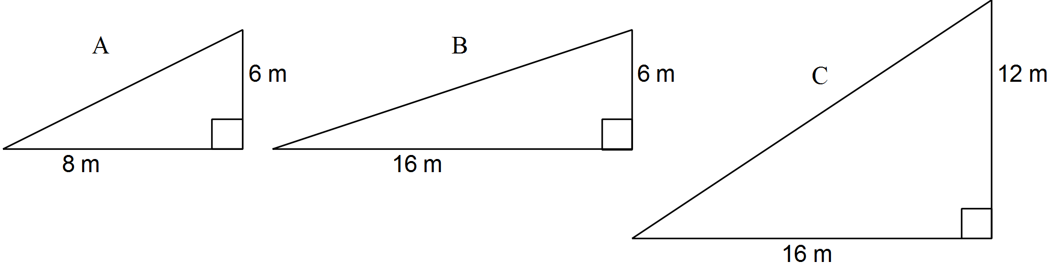

(a) Determine the area of lawn A.

(b) The scale factor for the area of lawn B compared to lawn A is 2.

What is the scale factor for the area of lawn C compared to lawn A?

(c) Lawn D (not pictured here) is 4 times as long as lawn A and 4 times as wide.

What is the scale factor for the area of lawn D compared to lawn A?

(d) There are other lawns which are similar to lawn A. One of these is lawn K for which the scale factor for the area of lawn K compared to lawn A is 10.

Sketch and label two possible diagrams to represent lawn K.

**Question 15 [1,1,1,1:4 marks]**

Triangle ABC is similar to triangle PQR.

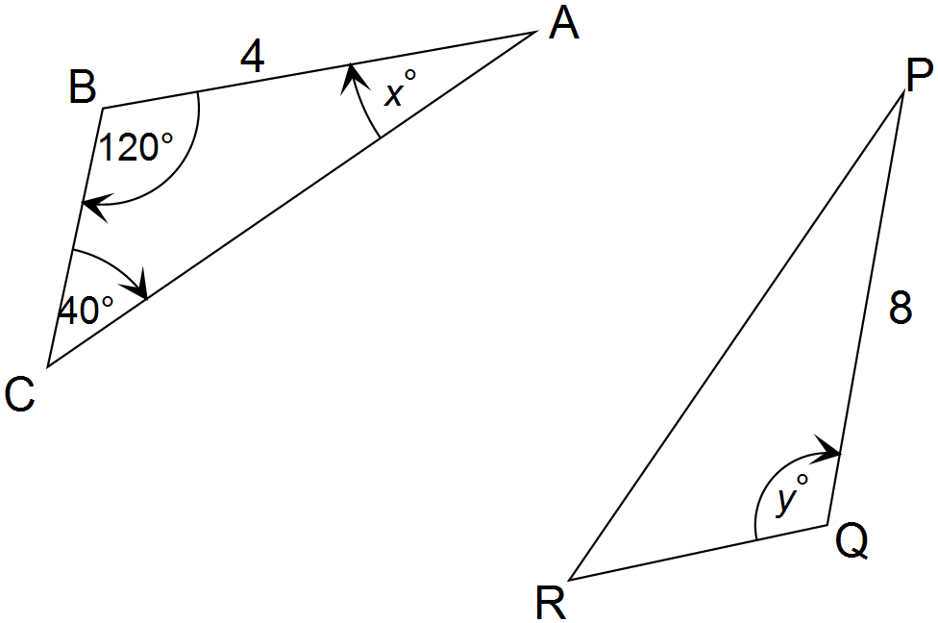

State the values of:

(a) *x*

(b) *y*

(c) 

(d) PR : AC